**Name: Dhananjay Narayan Kuber**

**Roll No.: 35036**

**Subject: Cloud Computing**

**Lab Assignment No. 01**

**Title: Install Google App Engine. Create a hello world app and other simple web applications using Python/ Java**

1. Download and install Google Cloud SDK from <https://cloud.google.com/sdk/docs/install#windows>
2. Grant Google account access to the CLI
3. Create main.py and write simple code to render Hello World!

**main.py**

import webapp2

class MainPage(webapp2.RequestHandler):

def get(self):

self.response.out.write("Hello, webapp2 World!")

app = webapp2.WSGIApplication([("/", MainPage)], debug=True)

1. Create app.yaml

**app.yaml**

application: pythonapp

runtime: python27

api_version: 1.0

threadsafe: true # allow multiple threads to access the app

handlers:

- url: /.*

script: main.app

1. Open Google Cloud SDK Shell and type

**py google-cloud-sdk\bin\dev_appserver.py <path of python project>**

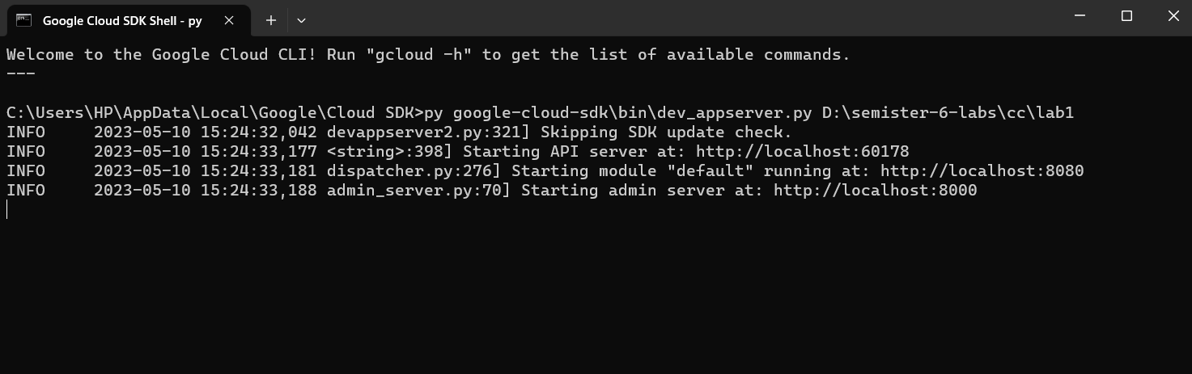

1. Open [**http://localhost:8080**](http://localhost:8080)to see web app on browser

